EXPERIMENT 3
3. Create a simple cloud software application for Car Booking Reservation System using any Cloud Service Provider to demonstrate SaaS include the necessary fields such as search for cabs, from, to, rental , out station, Package type, hours/Days etc.
Aim
To create a Car Booking Reservation System using Zoho One as a cloud-based Software as a Service (SaaS) application.
Procedure
- Log in to the Zoho One cloud platform.
- Open Zoho Creator from the Zoho One applications.
- Create a new application for the Car Booking Reservation System.
- Create a new form named Car Booking Reservation.
- Add the required fields:
  - Customer Name
  - Search for Cabs
  - From
  - To
  - Booking Type (Rental / Outstation)
  - Package Type
  - Hours/Days
  - Travel Date
  - Number of Passengers
  - Contact Number
- Configure the field types according to the data required.
- Design and arrange the form for easy user interaction.
- Save and publish the form.
- Enter sample cab booking details into the form.
- Submit the form and verify that the entered data is stored in the cloud.
- Test the application by entering different cab booking details, including rental and outstation bookings with different package types and durations.
- Verify that the Car Booking Reservation System works successfully as a SaaS application.

INPUT

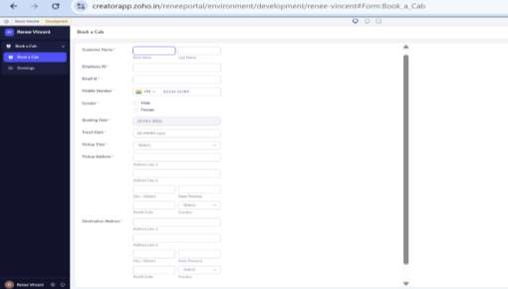

OUTPUT

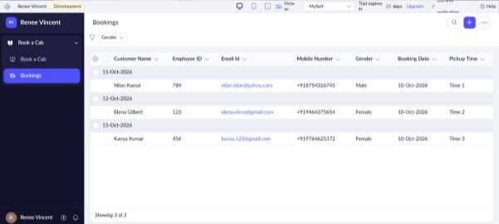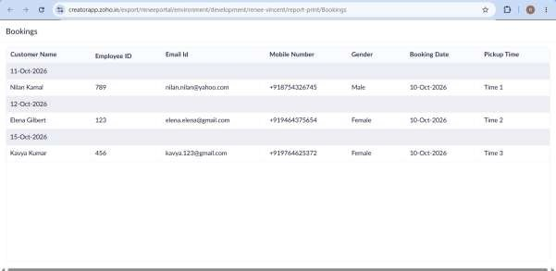
RESULT
Thus, a Car Booking Reservation System was successfully created using Zoho One and demonstrated as a Software as a Service (SaaS) application.

